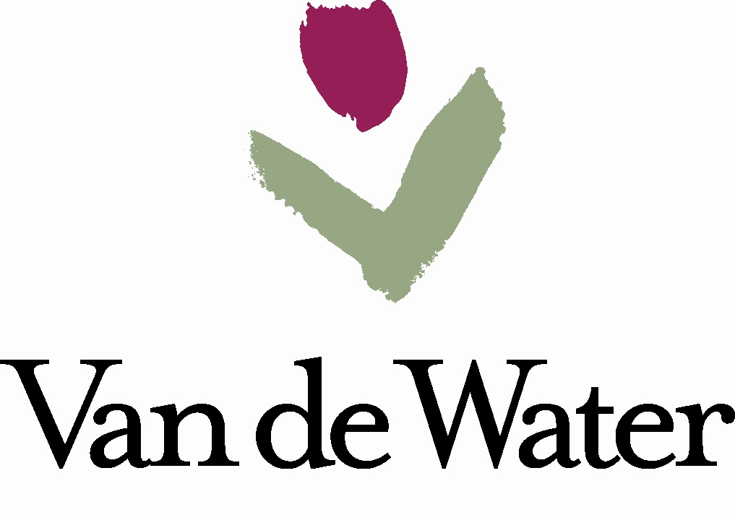
VDW Metropolitan District No. 2
Frequently Asked Questions (2019)

- What are Metropolitan Districts and why do they exist?
Metropolitan Districts are governmental entities and political subdivisions of the State of Colorado organized under Title 32 C.R.S. Metropolitan Districts are designed to provide essential services and serve as perpetual quasi-municipal corporations, operating with an elected Board of Directors. For more information about special districts in Colorado please visit the Division of Local Government (DOLA) website: https://dola.colorado.gov/lgis/
The VDW Metropolitan District No. 2 (District) was organized in 2002 under Title 32 C.R.S, with authorization from the City of Loveland, to provide vital services and construct public improvements such as sanitary sewer and water infrastructure, storm drainage, streets, traffic safety and signalization, and park and recreation amenities.
- What Public Improvements did the District construct?
To serve the VDW community, the District constructed sanitary sewer and water infrastructure, storm drainage, streets, traffic safety and signalization, and park and recreation amenities.
- How is the District funded?
The District is funded via a mill levy which is assessed to each property owner as a part of their annual
property taxes. The current District mill levy is 50.633, the maximum allowed for this District. The current overall mill levy on properties within District No. 2 is 132.933.
Tax District | 2216
Mill Levy | 132.933
Levy | Tax Authority
50.633 | VAN DE WATER METRPOLITAN #2
37.406 | THOMPSON R2-J GEN FUND
22.403 | LARIMER COUNTY
9.564 | LOVELAND
10.022 | THOMPSON R2-J BOND PYMT
1.763 | THOMPSON VALLEY HLTH SVC DST
1.000 | N COLO WATER CONS DIST
0.142 | LARIMER CO PEST CTRL DST

Sample Calculation:
$300,000 Actual Value X 7.2% assessment rate = $21,600. $21,600 assessed value/divided by 1,000 (mill levy applies to every $1,000 of value) x 132.933 =
$2,871 paid in annual property taxes

- How is the District governed and managed?
The District is governed by a five-member Board of Directors and meets on a quarterly basis. Meeting notices are posted on the City’s public bulletin board, with the Larimer County Clerk & Recorder, and at three locations within the District at least 72 hours in advance of meetings.

The District retains Pinnacle Consulting Group for Management and Finance/Accounting services. The District Manager is Ryan Abbott. He can be reached by phone at 970-669-3611 ext. 133 or via email at RyanA@PinnacleConsultingGroupInc.com.

